**Lab Submission**

**Instructor: Basit Ali**

**Assignment-03**

* Hive
* Show databases;

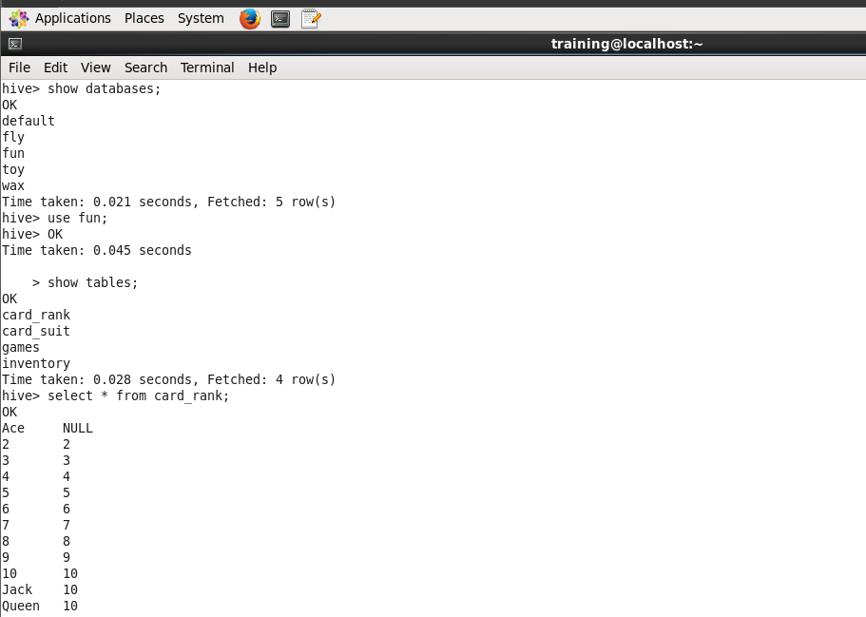

* Use **fun**;
* Show tables;



* Select * from card_rank;
* Select * from card_suit;
* Select * from games;

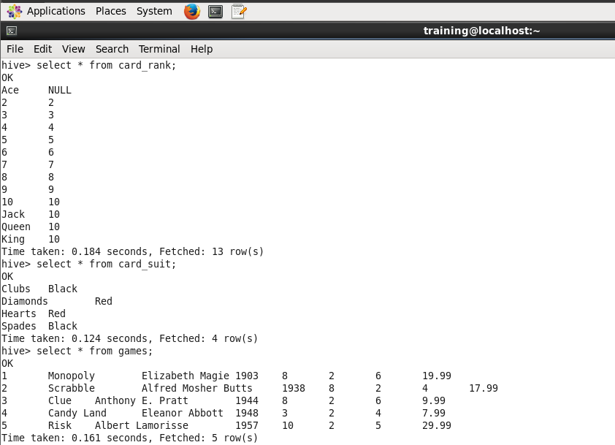

* Select * from inventory;

